

**Carnforth High School**

**Work Experience Booklet**

**26th – 30th June 2023**

**Key Information**

**NOTE**: You can access this information online by logging in to your Unifrog account from the Carnforth High School and going to ‘Placements.’

|  |  |
| --- | --- |
| **Student Name and Form** |  |
| **Placement Name** |  |
| **Placement Address** |  |
| **Placement Leader** |  |
| **Placement Telephone** |  |
| **Placement Email** |  |
| **Working Hours** |  |
| **Dress Code** |  |
| **Important Notes**  (for example, bus times and locations, etc.) |  |



**Wellbeing and Safeguarding**

**If you are ill and cannot attend your Work Experience placement you must contact school AND your employer as soon as possible**. Do this by calling school on 01524 732424 and your employer by the number they have given you (you should have recorded it on the front page of this booklet).

**Your employer has also been asked to call us if you do not arrive.**

Your wellbeing and safety are the most important thing to us. We will aim to visit you at your placement within the first three days to make sure everything is going well.

Every child & young person has a right to be safe. **Safeguarding means keeping you safe from any type of harm or neglect.**

All adults have a responsibility to protect you and it is the role of your parents or carers, and adults such as teachers, learning mentors, doctors, nurses, social workers, police officers, faith leaders and sports coaches, to ensure that you are safe. Wherever you are and whatever you are doing, whether you are at home, school or are chatting online, you have the right to grow up safe from people hurting you or failing to ensure that you are cared for.

If you are worried about something that is happening to you, or someone you know, you don’t have to deal with it on your own – visit the **Childline** website for advice [www.childline.org.uk](https://www.childline.org.uk/info-advice/you-your-body/getting-help/asking-adult-help/). (Childline is not just for young children!)

More information about what abuse can look like and how to keep safe can be found below and on the **NSPCC** website [www.nspcc.org.uk](https://www.nspcc.org.uk/preventing-abuse/child-abuse-and-neglect/).

A great guide written by young people who have experienced abuse or neglect can be found on the **SCIE** website [www.nice.org.uk](https://www.nice.org.uk/about/nice-communities/social-care/quick-guides/getting-help-to-overcome-abuse).

If you have any other problems or concerns during your placement please speak to your employer in the first instance, if relevant, or **call school and ask to speak to Mr Fox or Miss Jack on 01524 732424.**



**0808 800 5000**

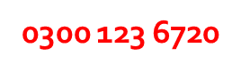



**101 or 999**





**111**

**Health and Safety**

All workplaces have some hazards which can cause harm, illness or damage to health or property. **Your employer must give you any important health and safety information on your first day.**

Please make sure that whilst you are on Work Experience you:

* Act responsibly
* Do not endanger yourself or others
* Follow the health and safety rules and signs
* Report anything you feel is dangerous, such as spillages, etc.

|  |
| --- |
| **Please list any important health and safety information you’ve been given here:** |
|  |

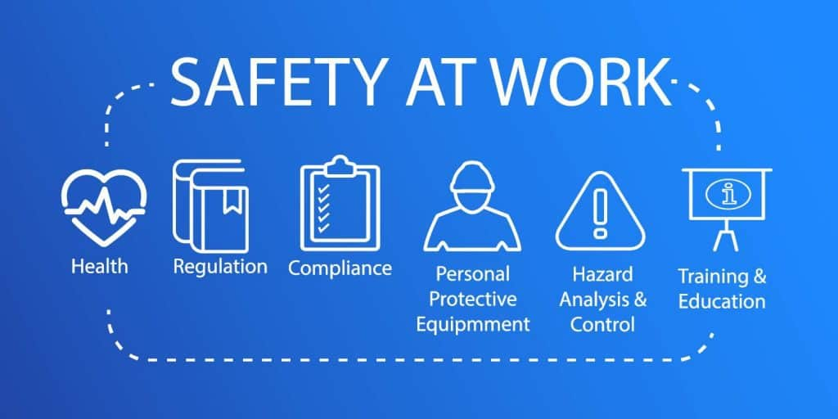

**Daily Diary**

When you return from Work Experience you’ll be completing a review of your experiences. Try to complete a record of what you do each day, recording **tasks** (such as inputting data) and **skills** (such as communicating with customers). Give each day a rating out of 10.

|  |  |  |  |
| --- | --- | --- | --- |
| **Day** | **Tasks Completed** | **Skills Developed** | **Rating** |
| **Monday** |  |  |  |
| **Tuesday** |  |  |  |
| **Wednesday** |  |  |  |
| **Thursday** |  |  |  |
| **Friday** |  |  |  |



**Reflecting on Your Work Experience**

Complete these boxes at the end of your placement to reflect on what you’ve learned over the week.

|  |  |
| --- | --- |
| **What I did well and I am proud of** |  |
| **Qualifications I would need to do this job** |  |
| **What I learnt about the world of work** |  |
| **The most important things I did on my placement** |  |
| **Skills I realised I’m strong in** |  |
| **Skills I realised I need to work on** |  |
| **What I might do differently next time** |  |
| **How Work Experience has helped me prepare for the world of work** |  |



**Additional Notes**

Use this space to record any additional notes, such as questions to ask your employer or the member of staff that visits you, reminders, such as jobs you need to do, things you need to bring, etc.

|  |
| --- |
|  |

